**PIZZA SALES SQL QUERIES**

**A. KPI`s**

1. **Total Revenue:**

select sum(total_price) from pizza_sales_copy;



1. **Average Order Value:**

select (sum(total_price)/count(distinct(order_id))) as Avg_Order_Value

from pizza_sales_copy;



1. **Total_Pizza_Sold:**

select sum(quantity) as Total_Pizza_Sold

from pizza_sales_copy;



1. **Total_Orders:**

select count(distinct order_id) as Total_Orders

from pizza_sales_copy;



1. **Avg_Pizzas_Per_Order:**

select cast(cast(sum(quantity) as decimal(10,2)) /

cast(count(distinct order_id) as decimal(10,2)) as decimal(10,2))

as Avg_Pizzas_Per_Order

from pizza_sales_copy;



**B. Hourly Trends for Total Pizzas Sold**

select hour(order_time) as order_hours, sum(quantity) as total_pizzas_sold

from pizza_sales_copy

group by hour(order_time)

order by hour(order_time);

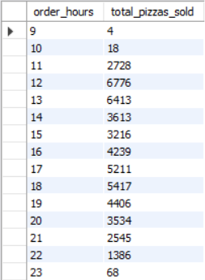

**C. Weekly Trends for Orders**

select

week(order_date, 3) as WeekNumber,

year(order_date) as Year,

count(distinct order_id) asTotal_orders

from

pizza_sales_copy

group by

week(order_date, 3),

year(order_date)

order by

Year, WeekNumber;

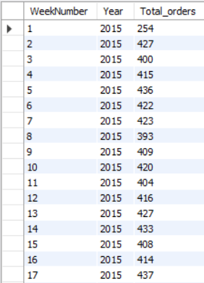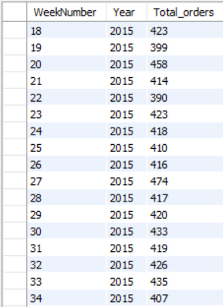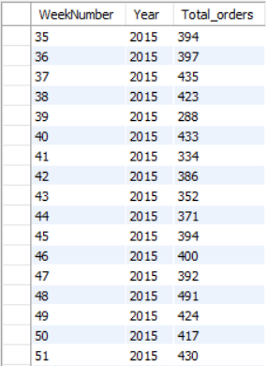

**D.Percentage of Sales by Pizza Category**

select pizza_category , cast(sum(total_price) as decimal(10,2)) as total_revenue,

cast((sum(total_price) * 100) / (select sum(total_price) from pizza_sales_copy )as decimal(10,2)) as PCT

from pizza_sales_copy

group by pizza_category

order by PCT desc;

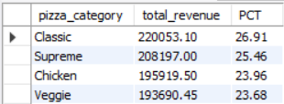

**E. Percentage of Sales by Pizza Size**

select pizza_size, cast(sum(total_price) as decimal(10,2)) as total_revenue,

cast((sum(total_price) * 100)/(select sum(total_price) from pizza_sales_copy) as decimal(10,2)) as PCT

from pizza_sales_copy

group by pizza_size

order by PCT desc;

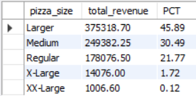

**F. Total Pizzas Sold by Pizza Category**

select pizza_category, sum(quantity) as Total_Quantity_Sold

from pizza_sales_copy

group by pizza_category

order by Total_Quantity_Sold desc;

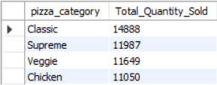

**G. Top 5 Pizzas by Revenue**

select pizza_name, sum(total_price) as Total_Revenue

from pizza_sales_copy

group by pizza_name

order by total_revenue desc

limit 5;

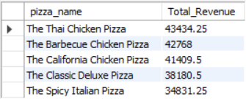

**H. Bottom 5 Pizzas by Revenue**

select pizza_name, sum(total_price) as Total_Revenue

from pizza_sales_copy

group by pizza_name

order by total_revenue asc

limit 5;

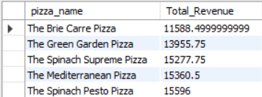

**I. Top 5 Pizzas by Quantity**

select pizza_name, sum(quantity) as Total_Pizzas_Sold

from pizza_sales_copy

group by pizza_name

order by Total_Pizzas_Sold desc

limit 5;

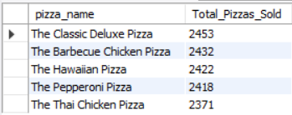

**J. Bottom 5 Pizzas by Quantity**

select pizza_name, sum(quantity) as Total_Pizzas_Sold

from pizza_sales_copy

group by pizza_name

order by Total_Pizzas_Sold asc

limit 5;

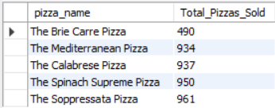

**K. Top 5 Pizzas by Total_Orders**

select pizza_name, count(distinct order_id) as Total_Orders

from pizza_sales_copy

group by pizza_name

order by Total_Orders desc

limit 5;

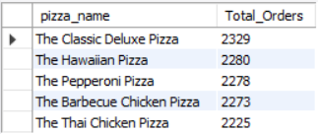

**L. Bottom 5 Pizzas by Total_Orders**

select pizza_name, count(distinct order_id) as Total_Orders

from pizza_sales_copy

group by pizza_name

order by Total_Orders asc

limit 5;

